Pet Resume
Applicant’s Name: |  | [ Paste Photo Here ]
Phone Number:
Email:
Pet’s Name:
Type of Pet:
Pet Overview:
Education/Training:
Experience:
Health:
Grooming:
Interests:
Achievements:
About Us:

Reference #1
Reference #2
Reference #3
This pet resume has been adapted from the SPCA “Sample” Pet Resume

Resume of Fluffy Malone
Applicant’s Name: | Libby Malone | 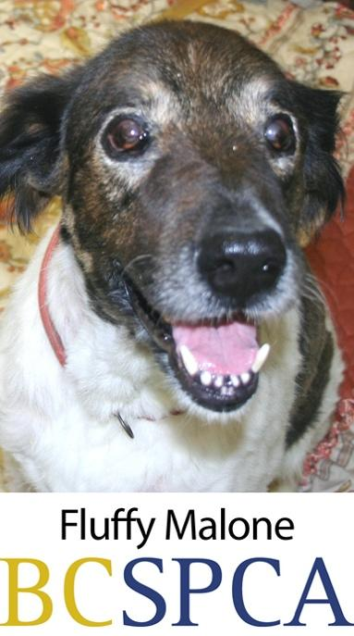
Phone Number: | 604-123-4567
Address | 1234 Palm Street, Vancouver, BC, Canada
Pet’s Name: | Fluffy Malone

A bit Fluffy: | Fluffy is a 60-pound, seven-year-old spayed female Chow Chow/German shepherd mix who gets along well with other dogs and people. Fluffy is quiet, housebroken and well-trained.
Education/Training: | Fluffy knows both hand signals and verbal commands. She comes when she is called, walks well on a leash and has graduated from beginner and intermediate obedience classes.
Experience: | Fluffy is a calm, well-adjusted dog who is used to being alone in a small apartment when her guardians are away at work. She only barks when she hears someone at the door or on occasions when there are fireworks in the vicinity, such as on Halloween.
Health: | Fluffy takes allergy medication daily, and flea medication to prevent fleas. Otherwise, she is in optimum health and goes for regular annual checkups with the veterinarian to ensure she is up to date on all her vaccinations, including rabies and kennel cough.
Grooming: | Fluffy’s breed requires that she is brushed regularly to prevent excess, uncontrollable shedding around the house. Fur that is removed is always neatly disposed of in the garbage.
Interests: | Fluffy enjoys three walks a day during the week, and even more on weekends when her guardians can take her hiking or to the beach.
Special Achievements: | Fluffy gives blood to help other animals in need and is a companion visitor at a local seniors’ home. Fluffy’s dog licence is up to date.
About Us: | We are responsible dog guardians who have had companion animals for the last 15 years. We take Fluffy for walks three times a day during the week, and run her on local trails on the weekends.
References: | Good Dog Training (604-123-1234)  Healthy Pet Vet (604-234-2345)  Mr. Former Landlord (604-345-3456)

